# ORDROID VS RPI PI B+

### Hardware comparaison

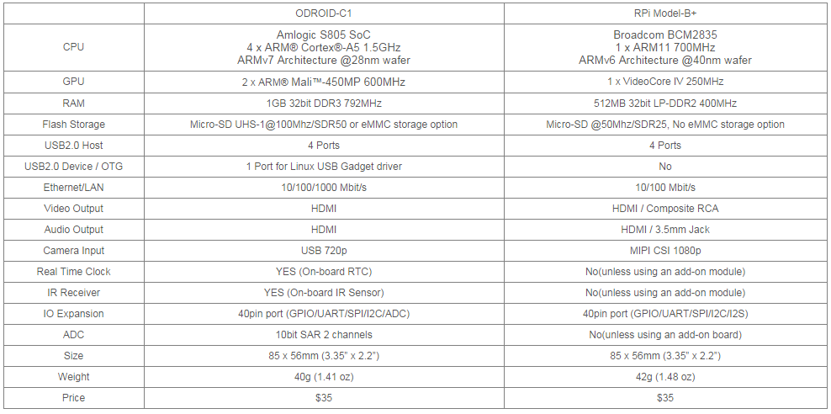

### Computing performance comparaison

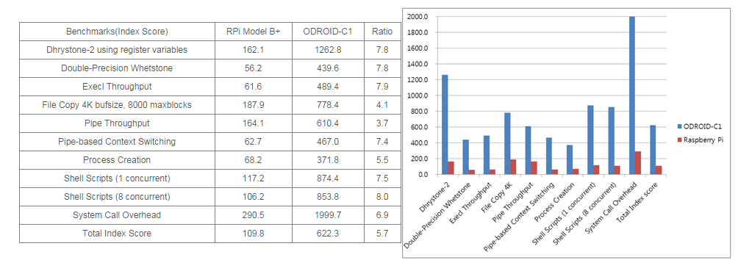

### Storage I/O Comparaison

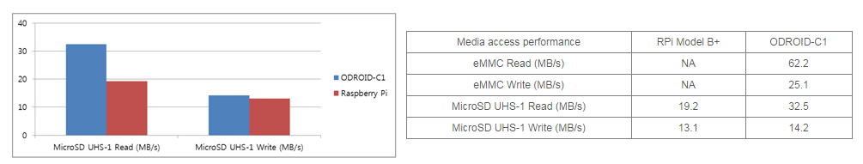

### Ethernet IO comparison